**Experiment No. 07**

**Object:**

1. To take console of Router using Console cable
2. To assign Ip Address to interfaces of Router using CLI mode.
3. To allow telnet of the Router to connected End-Devices

**Date:** March 17, 2018

# Configuration Figure:

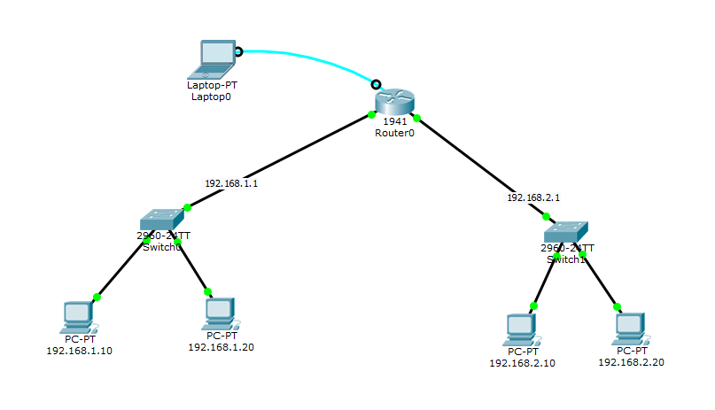

# Coding:

--- System Configuration Dialog ---

Continue with configuration dialog? [yes/no]: no

Press RETURN to get started!

Router>en

Router#conf t

Enter configuration commands, one per line. End with CNTL/Z.

Router(config)#line

Router(config)#line c

Router(config)#line console 0

Router(config-line)#logi

Router(config-line)#login lo

Router(config-line)#login local

Router(config-line)#username ali password 1234

Router(config)#ex

Router#

%SYS-5-CONFIG_I: Configured from console by console

Router#ex

Router con0 is now available

Press RETURN to get started.

User Access Verification

Username: ali

Password:

Router>en

Router#conf t

Enter configuration commands, one per line. End with CNTL/Z.

Router(config)#interface gigabitEthernet 0/0

Router(config-if)#ip address 192.168.1.1 255.255.255.0

Router(config-if)#no shutdown

Router(config-if)#

%LINK-5-CHANGED: Interface GigabitEthernet0/0, changed state to up

%LINEPROTO-5-UPDOWN: Line protocol on Interface GigabitEthernet0/0, changed state to up

Router(config-if)#ex

Router(config)#interface gigabitEthernet 0/1

Router(config-if)#ip address 192.168.2.1 255.255.255.0

Router(config-if)#no shutdown

Router(config-if)#

%LINK-5-CHANGED: Interface GigabitEthernet0/1, changed state to up

%LINEPROTO-5-UPDOWN: Line protocol on Interface GigabitEthernet0/1, changed state to up

ex

Router(config)#

Router(config)#line vty 0 5

Router(config-line)#transport input telnet

Router(config-line)#login local

Router(config-line)#username ali password 1234

Router(config)#ex

Router#

%SYS-5-CONFIG_I: Configured from console by console

Router#conf t

Enter configuration commands, one per line. End with CNTL/Z.

Router(config)#enable sec

Router(config)#enable secret 1234

Router(config)#ex

Router#

%SYS-5-CONFIG_I: Configured from console by console

ex

Router con0 is now available

Press RETURN to get started.

User Access Verification

Username:

# Telnet:

|  |  |
| --- | --- |
|  |  |

# Ping Test:

